NexTTyme LLC
www.nexttyme.com

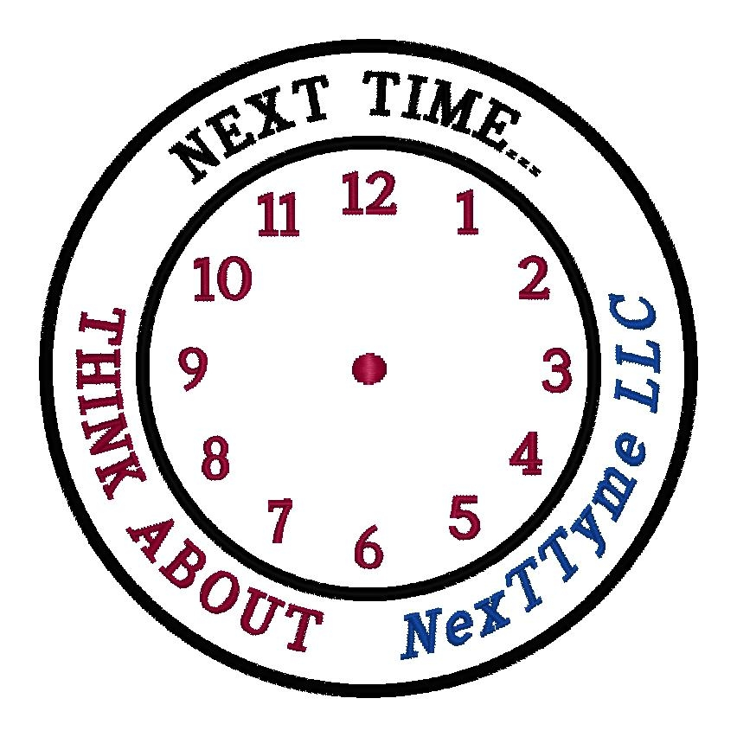
PO Box 620328
Charlotte, NC
28262
Phone (704) 786-2354
E-mail alertus@nexttyme.com
Web site http://www.nexttyme.com

Here are the States that have the SAME or SIMILAR statements in their Department of Transportation Driver’s Manual

“If you need help, tie a white cloth to the left door handle or the radio aerial and raise the hood of the car”

STATE
ALASKA
CONNECTICUT
DELAWARE
FLORIDA
HAWAII
IDAHO
IOWA
KANSAS
KENTUCKY
MARYLAND
MASSACHUSETTS
MINNESOTA
MISSOURI
MONTANA
NEW HAMPSHIRE
NORTH CAROLINA
OKLAHOMA
RHODE ISLAND
SOUTH CAROLINA
SOUTH DAKOTA
TEXAS
VERMONT
WASHINGTON
WISCONSIN
WYOMING

