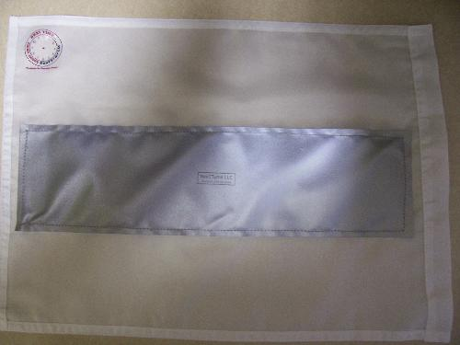
YOUR BEST FRIEND AT NIGHT!!
Our International Award Winning roadside assistance flag “AlertUs” has a 4X12in 3M reflective strip sewn onto both sides of a 12X18in Nylon (white) flag illuminates up to 1500 meters (1 MILE) to alert oncoming motorists of your DISABLED or PARKED vehicle! The reflective material is the same fabric used on Police, Fireman, DOT and Emergency Responders’ uniforms!
Your Partner For Safety
• NO ASSEMBLY REQUIRED
• NO ELECTRICAL HOOKUP NEEDED
• NO BATTERIES REQUIRED
• GREAT FOR COLLEGE STUDENTS
• GREAT FOR CONSULTANTS
• GREAT FOR VEHICLE RENTAL CO.
• GREAT FOR AUTO INSURANCE CO.
• GREAT FOR BUSINESS FLEET
• IDEAL FOR CAR DEALERSHIPS
Let us show you how to keep your family, employees and friends safe while traveling!
“
NexTTyme LLC is a registered vendor of North & South Carolina Department of Transporation

Per National Highway Traffic Safety Administration, from 1990 – 2010 over 450 fatalities PER YEAR occur due to roadside accidents caused by DISABLED or PARKED vehicles due to low visibility!
A SOLUTION, rather than a PRODUCT for sale!

We are availalible to participate at Safety Campaigns!

Please call or visit us online for further details

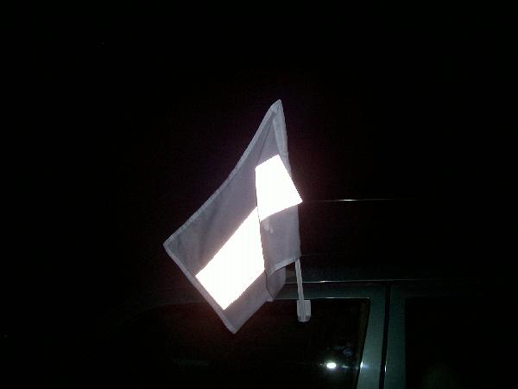

addressing the ROADSIDE SAFETY needs of FAMILIES!


”
P.O. BOX 620328
Charlotte, NC 28262
alertus@nexttyme.com
www.nexttyme.com

