NexTTyme LLC
www.nexttyme.com

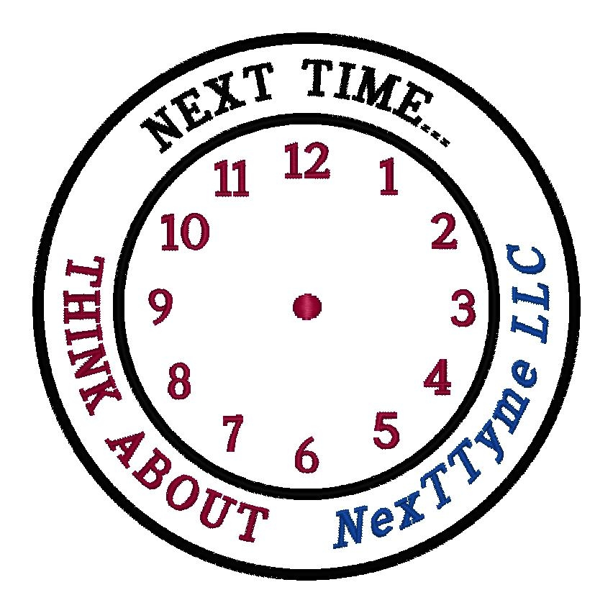
PO Box 620328
Charlotte, NC
28262
Phone (704) 786-2354
E-mail alertus@nexttyme.com
Web site http://www.nexttyme.com

Here is what NCDOT Driver’s Handbook instructs you to do in case of a ROADSIDE BREAKDOWN!

Breakdowns:

Do not attempt to make repairs on a vehicle while it is in an area exposed to other traffic. Ask a passing driver to get help for you by calling any law enforcement agency.
What you should do if your vehicle breaks down:
- Exit the main part of the road - move the vehicle completely onto the shoulder of the road.
- Make sure you leave the car by the passenger side, and do not allow passengers to remain in the car.
- Stand off the road and away from the car - do not stand in front or to the rear of the vehicle.
- If you need help, tie a white cloth to the left door handle or the radio aerial and raise the hood of the car.
- If it's dark, turn on the parking lights or emergency flashers. Always have flashlights or flares in your car for emergencies.

