NexTTyme LLC
www.nexttyme.com

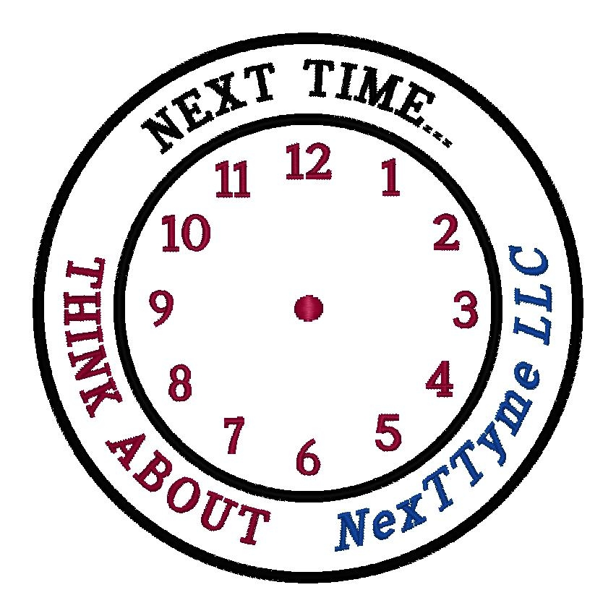
PO Box 620328
Charlotte, NC
28262
Phone (704) 786-2354
E-mail alertus@nexttyme.com
Web site http://www.nexttyme.com

Not only will the “AlertUs” help prevent fatal accidents to the families inside the disabled or parked vehicle but, other (FAMILIES IN TRANSIT) motorist lives will be saved as well by avoiding an accident due to low visibility!

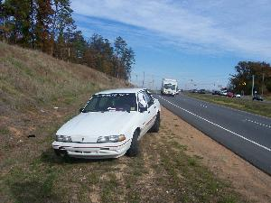

“Best Practices”

for most States... (Vehicle Safety)
Tail Lights:
Vehicles and motorcycles must have at least one red light mounted on the rear.
All other motor vehicles, trailers, and semi-trailers must have at least two red lights mounted on the left and right rear.
These taillights must be visible at least 500 feet to the rear.... whereas the AlertUs Flag (3M Reflective Fabric Strip) will illuminate up to 1500 meters!

